שבירות ושלימות
Brokenness and Wholeness: A Mosaic of Meaning

שבר

שלם

Take a look at the two Hebrew words. Just by looking at them, can you tell which means broken and which means whole?

If you know Hebrew, write all the meanings or combinations you can think of for the two words.

שבר

שלם

Or, write all the meanings or combinations you can think of for the English words broken (break, etc)
and for whole (make whole, complete)

Break, broke

Make whole

Share the results with your partner. Any surprises? Any artistic sparks flying as you think about the various shades of meaning?

Source #1: Etymology of the words. How the Hebrew Language Grew, Horowitz.
שבר – (shavar) break, crash
Breaking is a concept around which many words would naturally cluster. So many things in the world get broken. One of the commonest forms of purposeful breaking in ancient times before coins were invented was the breaking of bits of silver for making purchases. So שבר (shavar)came to mean to buy and שבר (shever) the thing bought. Since the item most commonly bought was grain, (shever)שבר, came to mean grain.
השביר -sell because you made someone break silver
שבר – also came to mean the interpretation of a dream; i.e. breaking it down.
משבר – crisis, the breakdown of the economic system.
משברי ים - breakers of the sea
שבר - a fracture

שלם—Be Whole, Complete
It probably never occurred to you and it may faintly amuse you to know that when someone says to you inquiringly, מה שלומך, he is actually asking whether you are whole, complete, in one piece. They want assurance that no part of you—fingers, toes, legs, arms, etc. is missing or broken. The root of our familiar greeting word (shalom) שלום is שלם whole, complete. If you’re whole, you’re probably well and at peace.
- -the reflexive, means to perfect oneself השתלם
שלם -to pay for something carries the meaning to restore or make whole again. By paying a person for what you took from him you fill the gap you created in his possessions when you first took the item.
שלימות- entirety
תשלום- payment, may mean bribe
השלים- the hifil, causative, pattern could mean either made peace or made whole.
It is interesting to note that the English greeting, “Hail” has the same meaning as Shalom, namely, being whole. When someone says “Hail” he is wishing that you are whole. “Hale in the expression “Hale and hearty” is the same word as “hail”. He Hebrew word Shalom has given rise to a number of English words. There is Salem, a town in Massachusetts. “Salaam” is the cry of greeting spoken to a ruler or prince; it is usually accompanied by deep bows. Scholars say the English words Farewell comes from “salaam.”

'

Source #2- Brokenness and Wholeness in the context of a Psalm 147

Scan the psalm to see how the root sh-v-r (break) and the root sh-l-m (make whole) are used in context. What is breaking and what is made whole in the psalm? Can you relate to this as you think about this past covid year? This pattern repeats in other psalms where the psalmist feels broken, turns to consider God’s power both in the political and natural world, and then prays for wholeness—well being and inner peace.

הַ֥לְלוּ יָ֨הּ ׀ כִּי־ט֭וֹב זַמְּרָ֣ה אֱלֹהֵ֑ינוּ כִּֽי־נָ֝עִים נָאוָ֥ה תְהִלָּֽה
Hallelujah. It is good to chant hymns to our God; it is pleasant to sing glorious praise.
בּוֹנֵ֣ה יְרוּשָׁלִַ֣ם יְהוָ֑ה נִדְחֵ֖י יִשְׂרָאֵ֣ל יְכַנֵּֽס׃
The LORD rebuilds Jerusalem; He gathers in the exiles of Israel.
הָ֭רֹפֵא לשְׁב֣וּרֵי לֵ֑ב וּ֝מְחַבֵּ֗שׁ לְעַצְּבוֹתָֽם׃
He heals their broken hearts, and binds up their wounds.
מוֹנֶ֣ה מִ֭סְפָּר לַכּוֹכָבִ֑ים לְ֝כֻלָּ֗ם שֵׁמ֥וֹת יִקְרָֽא׃
He reckoned the number of the stars; to each He gave its name.
גָּד֣וֹל אֲדוֹנֵ֣ינוּ וְרַב־כֹּ֑חַ לִ֝תְבוּנָת֗וֹ אֵ֣ין מִסְפָּֽר׃
Great is our Lord and full of power; His wisdom is beyond reckoning.
מְעוֹדֵ֣ד עֲנָוִ֣ים יְהוָ֑ה מַשְׁפִּ֖יל רְשָׁעִ֣ים עֲדֵי־אָֽרֶץ׃
The LORD gives courage to the lowly, and brings the wicked down to the dust.
עֱנ֣וּ לַיהוָ֣ה בְּתוֹדָ֑ה זַמְּר֖וּ לֵאלֹהֵ֣ינוּ בְכִנּֽוֹר׃
Sing to the LORD a song of praise, chant a hymn with a lyre to our God,
הַֽמְכַסֶּ֬ה שָׁמַ֨יִם ׀ בְּעָבִ֗ים הַמֵּכִ֣ין לָאָ֣רֶץ מָטָ֑ר הַמַּצְמִ֖יחַ הָרִ֣ים חָצִֽיר׃
who covers the heavens with clouds, provides rain for the earth, makes mountains put forth grass;
נוֹתֵ֣ן לִבְהֵמָ֣ה לַחְמָ֑הּ לִבְנֵ֥י עֹ֝רֵ֗ב אֲשֶׁ֣ר יִקְרָֽאוּ׃
who gives the beasts their food, to the raven’s brood what they cry for.
לֹ֤א בִגְבוּרַ֣ת הַסּ֣וּס יֶחְפָּ֑ץ לֹֽא־בְשׁוֹקֵ֖י הָאִ֣ישׁ יִרְצֶֽה׃
He does not prize the strength of horses, nor value the fleetness of men;
רוֹצֶ֣ה יְ֭הוָה אֶת־יְרֵאָ֑יו אֶת־הַֽמְיַחֲלִ֥ים לְחַסְדּֽוֹ׃
but the LORD values those who fear Him, those who depend on His faithful care.
שַׁבְּחִ֣י יְ֭רוּשָׁלִַם אֶת־יְהוָ֑ה הַֽלְלִ֖י אֱלֹהַ֣יִךְ צִיּֽוֹן׃
O Jerusalem, glorify the LORD; praise your God, O Zion!
כִּֽי־חִ֭זַּק בְּרִיחֵ֣י שְׁעָרָ֑יִךְ בֵּרַ֖ךְ בָּנַ֣יִךְ בְּקִרְבֵּֽךְ׃
For He made the bars of your gates strong, and blessed your children within you.
הַשָּׂם־גְּבוּלֵ֥ךְ שָׁל֑וֹם חֵ֥לֶב חִ֝טִּ֗ים יַשְׂבִּיעֵֽךְ׃
He endows your realm with well-being, and satisfies you with choice wheat.
הַשֹּׁלֵ֣חַ אִמְרָת֣וֹ אָ֑רֶץ עַד־מְ֝הֵרָ֗ה יָר֥וּץ דְּבָרֽוֹ׃
He sends forth His word to the earth; His command runs swiftly.
הַנֹּתֵ֣ן שֶׁ֣לֶג כַּצָּ֑מֶר כְּ֝פ֗וֹר כָּאֵ֥פֶר יְפַזֵּֽר׃
He lays down snow like fleece, scatters frost like ashes.
מַשְׁלִ֣יךְ קַֽרְח֣וֹ כְפִתִּ֑ים לִפְנֵ֥י קָ֝רָת֗וֹ מִ֣י יַעֲמֹֽד׃
He tosses down hail like crumbs— who can endure His icy cold?
יִשְׁלַ֣ח דְּבָר֣וֹ וְיַמְסֵ֑ם יַשֵּׁ֥ב ר֝וּח֗וֹ יִזְּלוּ־מָֽיִם׃
He issues a command—it melts them; He breathes—the waters flow.
מַגִּ֣יד דברו [דְּבָרָ֣יו] לְיַעֲקֹ֑ב חֻקָּ֥יו וּ֝מִשְׁפָּטָ֗יו לְיִשְׂרָאֵֽל׃
He issued His commands to Jacob, His statutes and rules to Israel.
לֹ֘א עָ֤שָׂה כֵ֨ן ׀ לְכָל־גּ֗וֹי וּמִשְׁפָּטִ֥ים בַּל־יְדָע֗וּם הַֽלְלוּ־יָֽהּ׃
He did not do so for any other nation; of such rules they know nothing. Hallelujah.

Source #3—A Poem by Leah Goldberg (1911-1970. Aliyah in 1935)
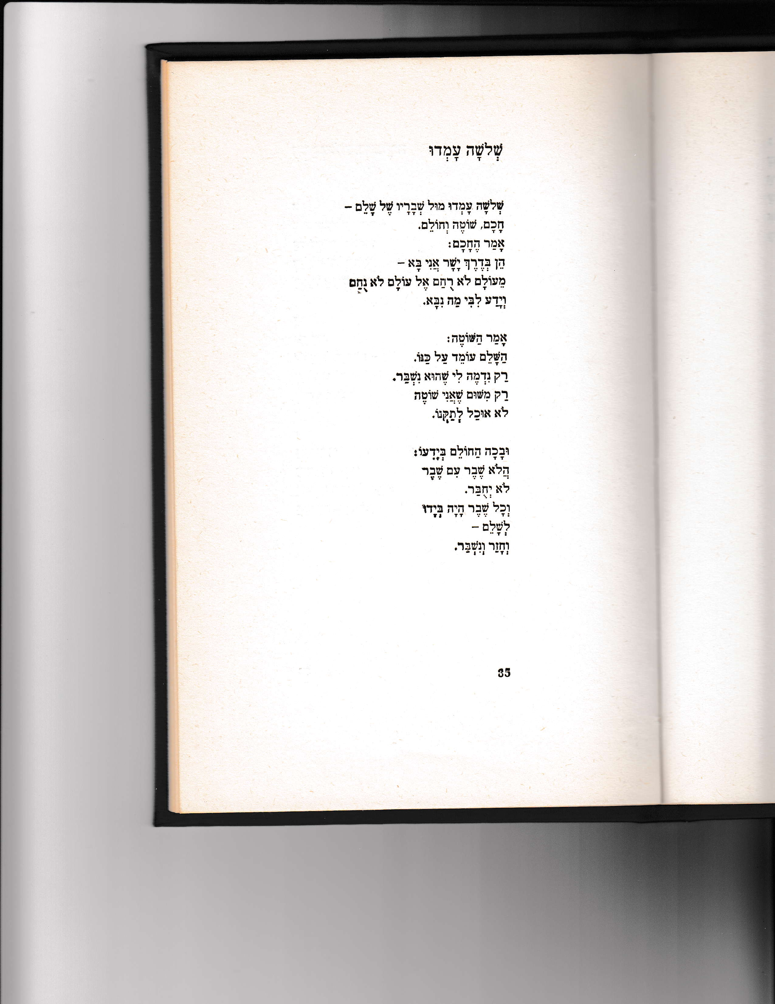
Three Were Standing

Leah Goldberg

Three were standing near the shards of the whole—
A scholar, a fool, and a dreamer.

Said the scholar:
“Upon my word, I come from the straight and narrow road—
From a world with no mercy to a world without comfort
And I knew in my heart what was prophesied.”

Said the fool:
“The whole remains in its place.
It only seems to me to be broken.
Only because I’m a fool,
I can’t fix it.”

And the dreamer wept knowing:
Isn’t it so that a shard with a shard
Will not be joined.
And each shard was in his hand
To complete ( or to pay)
And he returned and he broke.

Goldberg is clearly pitting the Hebrew words shavar and shalem against each other.
- What is absolutely and objectively true in this poem?
- How do the three people interpret what they see?
- Whose explanation appeals to you or do you have another way to view the shards, sh’varim?

Questions for Discussion

One of the words that comes from whole (שלם) is שלום which means peace. What idea connects wholeness and peace?

One of the words that comes from broken (שבר) is to interpret a dream. How do you understand the connection between dream interpretation and breaking?

Another use of “break” is to “break bread”- we literally break a piece of challah off one of our two whole challot for motzi. On Pesah we break the middle matzah (יחץ) right after eating the green vegetable (כרפס). What does breaking bread symbolize or mean for you? Why break the bread in front of everyone?

Brokenness and Wholeness and Art

The most obvious art form that uses broken material to create a whole is mosaic. Below is an article about the history of mosaic along with one of the earliest examples from a Jewish source. Note that it’s words, not pictures. The second image is from Tzippori or Sepphoris. It was an important Jewish village in the Galilee during rabbinic times and is now an archaeological park. Here you’ll see a human image in mosaic that was in an
Upper class home. The third image is from a synagogue in Beit Alpha, also in the Galilee.

Mosaic: Using broken to create whole

History
Mosaic is a beautiful art form, but where did it come from? From what we can tell, mosaics have been around for a very long time, perhaps as long as architecture itself. The oldest mosaics found date to the 3rd millennium BCE, in a temple in Mesopotamia. These ancient mosaics were made of stones, shells, and ivory, most of which were locally available products. It's worth noting that similar mosaics have been found in the Americas dating at least 250 CE (and possibly before) in the Maya civilization, where the art form was developed independently.

The oldest known mosaic in Israel is called the Mosaic of Rehob from Tel Rehov in Bet She’an. Notice the first word in the mosaic. To look more closely and see the pieces that make up the mosaic, see https://en.wikipedia.org/wiki/Mosaic_of_Rehob#/media/File:Ktovet_recov_AA.jpg

Image #1

Image #2
One of the most famous mosaics in Israel is in the Galilean city of Tzippori (Sepphoris). When the Artist Lab visited, we dubbed her the “Mona Lisa of Tzippori.” (2nd century CE). A synagogue has also been uncovered and its mosaics are similar in theme to those in Beit Alpha, i.e. zodiac, binding of Isaac. To see mosaics from the synagogue: https://www.pbs.org/wnet/story-jews/explore-the-diaspora/mosaic/

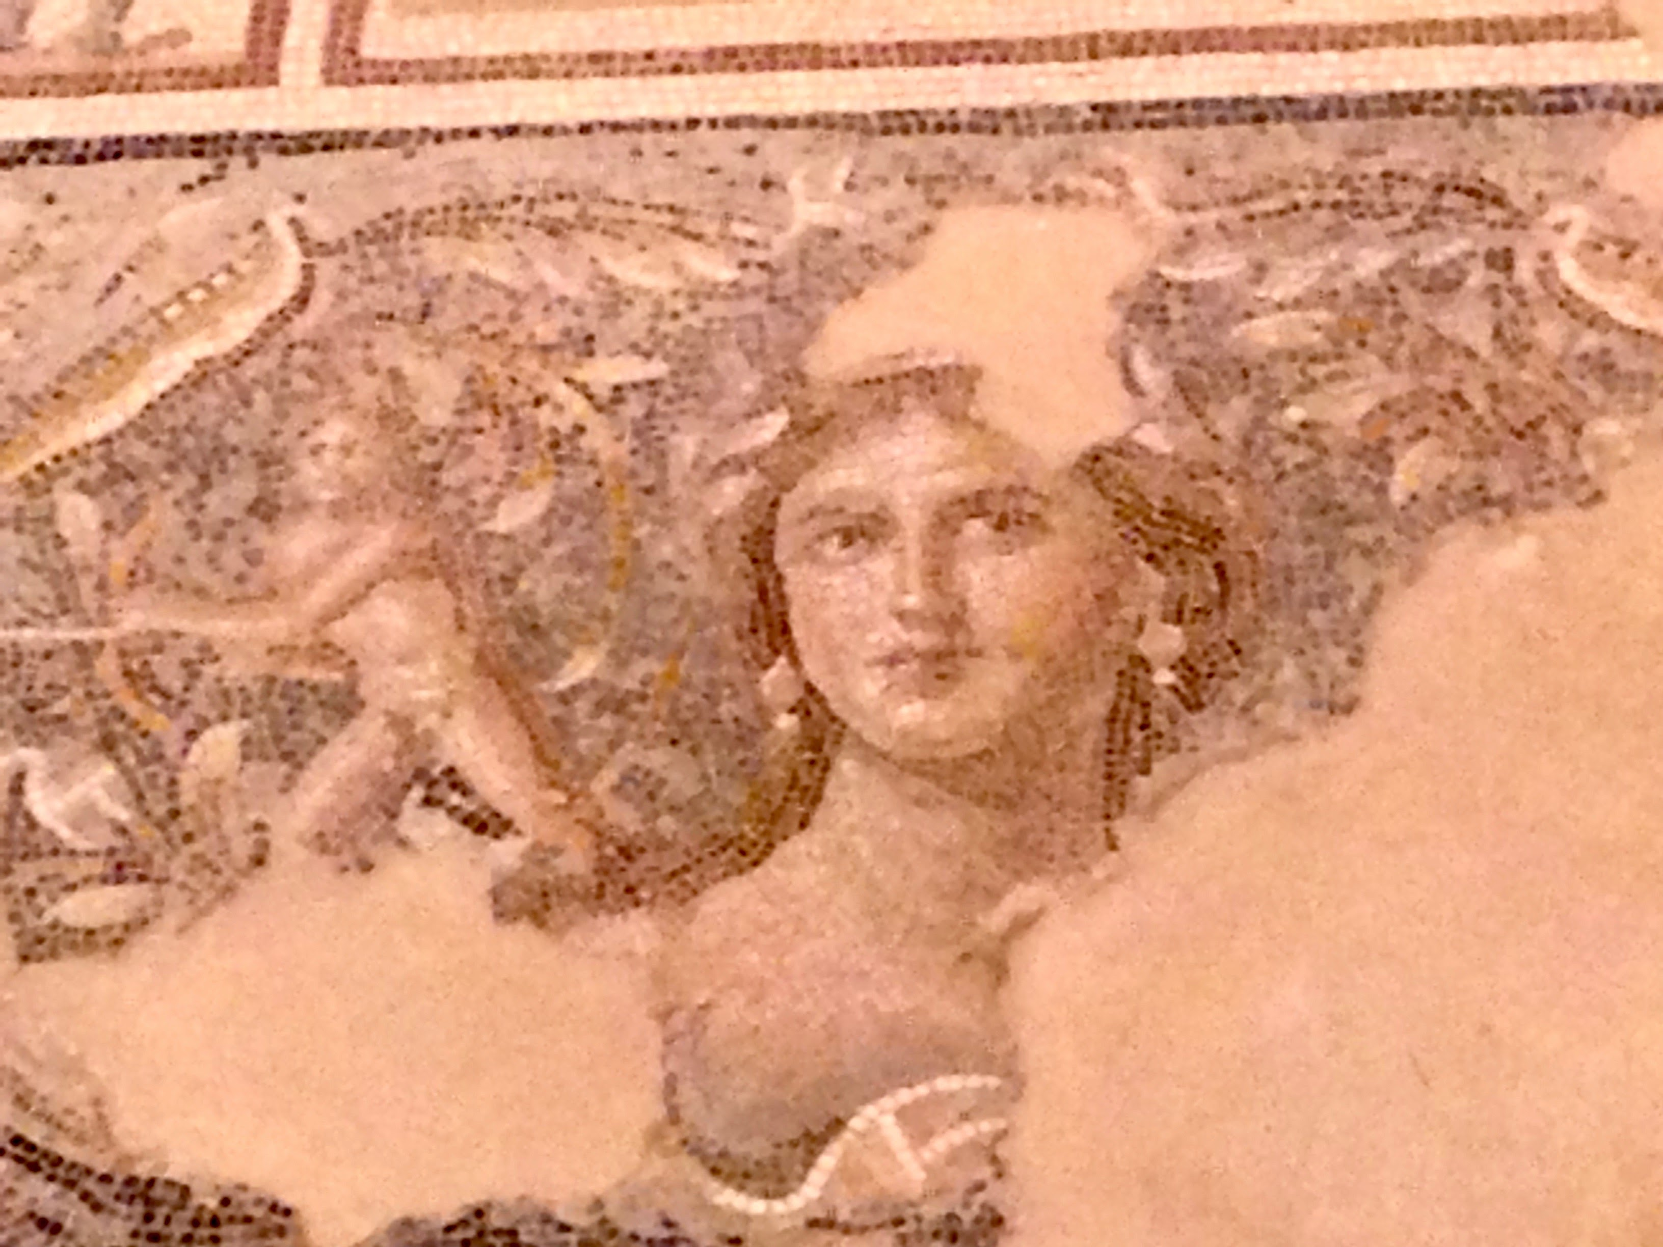

Image #3 Zodiac Mosaic from Beit Alpha Synagogue (5th-6th centuries)

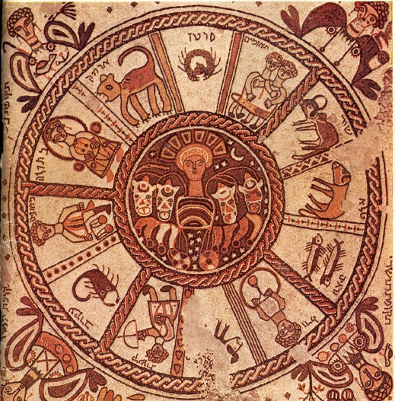

Brainstorming Art Medium

What art forms in addition to mosaic come to mind when you think about broken and whole?

Is there any art form you can think of that doesn’t create a wholeness out of brokenness?

Consider with your Hevruta
A Review
You may want to take some time to review the first two texts before delving into the multiple meanings and nuances of the two words.

The Torah text spoke about Moshe breaking the tablets when he was angry at the Israelites for worshipping the golden calf. God has him build an ark and rewrite the tablets. The rabbis wonder what happened to the broken pieces and conclude that they were kept together with the whole tablets.

The text from Maccabees described a broken Temple in Jerusalem that broke the spirit of the Maccabees who fought to save it. Judah steps in, organizes the soldiers into teams to guard the Temple and rebuild it. Broken stones are set aside, whole stones are used for the Temple. A holiday is declared to memorialize the rebuilding and making Temple worship possible again.

Introduction to these texts
Introduce the idea that in Hebrew we can build a large vocabulary from a root word and you’ll be examining what words and phrases are part of the family of shavar (break) and shalem (whole).

You can create a word mosaic or another art form from the responses to generating word connections. Many English phrases like broken-hearted, breakers (in the ocean) appear in Hebrew. In Hebrew a different verb is used for breaking the law, הפר, possibly because the law doesn’t really
break. The Hebrew root shalom is even more elastic. Peace in the Hebrew language is both a political concept and an emotional state. Fulfillment of one’s dream, being at peace with a situation all derive from the same Hebrew root.

Why these texts?
If you choose to look at either of these texts with your partner, you’re looking at the usage of the root sh-v-r and sh-l-m. In both the Biblical and 20th century poetic texts,
the words are used in opposition with a wide range of meanings.

Art Examples
This may be a week when you probe media you might use to express brokenness and wholeness. I picked the most obvious but you can generate lots more ideas from quilting to photography to painting to computer generated art. Any work of art takes a discrete element to create a whole. You may want to test out some ideas this week.
Sadly, the news has presented us another issue of breakage and trying to return to a
state of wholeness.

