Jewish Artist Lab March 16, 2021
שבירות ושלימות מלוות אותנו
Brokenness and Wholeness Embedded in Jewish Life

Brainstorm

- What Jewish rituals do you know that include breaking or tearing?
- What Jewish rituals do you know that break our hearts?
- What Jewish rituals do you know that heal our hearts?
- What Jewish laws do you know that involve breaking or making whole?

Back to Midrash: DIY Meaning for You and Your Pesach gathering

- How do Pesah rituals, laws and themes connect to brokenness and wholeness?

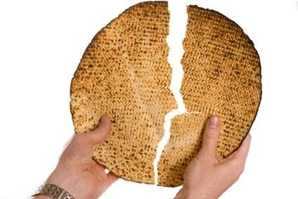

Focus on יחץ- Breaking the Middle Matzah (right after dipping the parsley)

- What is said when we break the middle matzah and hide the larger “half”?
- Why do we do this?

Create your own midrash or sketch about the symbol of breaking the middle matzah, hiding one half, and then eating the hidden half as an afikoman.

Discussion Questions
- How can rituals or celebrations help us move through the times when we feel broken?
- From examining the incorporation of breaking rituals into Jewish practice, what do you learn about the relationship of brokenness and wholeness—Sh’virut and Shleimut in Jewish life?
- Is shleimut the ideal? Is it possible?
- If not, how do we live with brokenness in our lives?

Suggestions for your hevruta
This material should be much easier for you and your partner than last month’s!

Brainstorming is usually a good strategy to begin a conversation. If your partner isn’t Jewish, this may be more difficult, but you could show a film clip with breaking the glass at a wedding. https://www.youtube.com/watch?v=ee-htWvXMIg shows 5:47 minutes of Fiddler on the Roof. The glass smashing comes at 5:45. The ceremony is shown to the song, Sunrise, Sunset so it does convey the idea of “laden with laughter and with tears.” There are LOADS of Jewish wedding videos on youtube so you can search for a more modern look.

Midrash
Reintroduce the idea that midrash creates personal meaning. A personal midrash may connect to contemporary events, feelings, family history—anything. There are examples of midrash built into the Passover seder like spilling wine from our cups to symbolize that we have to temper our happiness because the plagues caused the Egyptians to suffer.

Introduce the idea that breaking and making whole are a theme of the Pesach seder. Some partners will know that Yahatz (breaking the matzah) is the 4th step in the seder and will be
familiar with breaking the middle matzah into so-called halves with the larger half set aside for the afikoman. Most haggadot won’t include an explanation for this practice—just the “how to” directions.

Create a midrash.
A midrash can be a story, poem, artwork. Together or in parallel, create a midrash for the practice of yahatz.

On Passover—share your midrashim!

Sample Visual Midrash
(Rabbinical Assembly Haggadah: The Feast of Freedom)
Parting of the Red Sea by Dan Reisinger

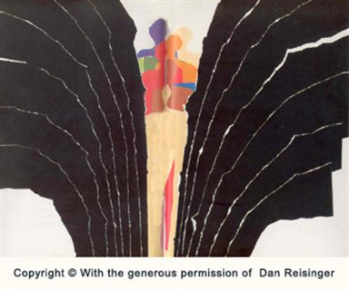

How did Dan Reisinger interpret the parting of the Red Sea?
Reisinger was from Serbia and fought with a Partisan unit during World War II. Most of his family was killed in the Holocaust. He made Aliyah to Israel with his mother and stepfather. To earn money he painted houses. At 16 he was the youngest student accepted to Bezalel School of Art in Jerusalem.
Do you sense any echoes of his personal history in his art?

History of Yahatz

This post Talmudic innovation in the Seder is credited to Rabbi Elazar ben Judah (12th century Germany). Rabbi Elazar lived in Worms. His wife and two daughters were killed by Crusaders. Rabbi Elazar and his son were wounded.

Rabbi Elazar wrote his own commentary on the Haggadah.

Extras
Listen to a podcast by Prof. Marc Michael Epstein about illustrated haggadot.
https://interleaved.buzzsprout.com/925780/8045543-pesachim-no-6-every-spring-is-illuminated

To see a new Haggadah of visual midrashim from the Chicago Jewish Artists Lab:

https://blogs.timesofisrael.com/creating-the-artists-haggadah/?utm_source=The+Blogs+Weekly+Highlights&utm_campaign=blogs-weekly-highlights-2021-03-11&utm_medium=email

