Jewish Artist Lab-May 25, 2021

השיחה בין שבירות ושלימות לפי הזוהר
A Conversation Between Brokenness and Wholeness

https://architizer.com/blog/practice/details/architecture-plus-kabbalah/
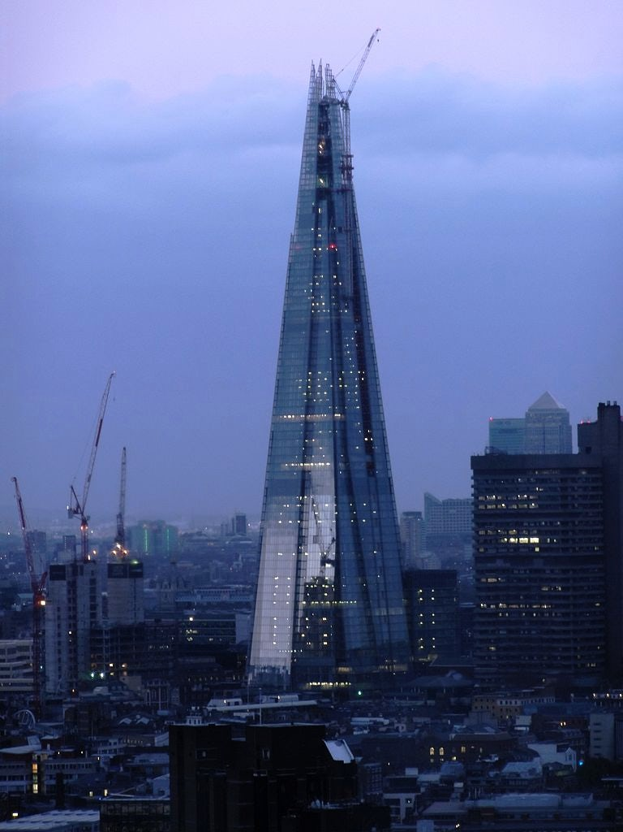
Renzo Piano’s The Shard . London
Source #1: Isaac Luria’s Mystical Vision of Creation
Summarized by Rabbi Jonathan Sacks

[Rabbi Luria] posed a question seemingly naïve in its simplicity yet far-reaching in its consequences: If God exists, how does the world exist? If God is infinite, filling the world with his presence and every place with his glory, how is there room—physical or metaphysical—for anything else? Two things cannot coexist at a single time in a single space. Infinity must always crowd out finitude. How then is there a universe?

Luria’s radical answer was the doctrine known as tzimtzum, a word that means contraction, self-effacement, withdrawal or concealment. God, he said, contracted into himself to leave a space for the world. The universe that unfolded day by day during the six phases of Genesis 1 was necessarily only the second stage of creation. The first was act of divine self-effacement, a withdrawal into himself on the part of God. The Hebrew word for ‘universe’ and ‘eternity’, olam, comes from the root ‘-l-m (ע-ל-מ) which also means ‘hiding’ or ‘concealment’. Only when God is hidden can the universe exist.

To this must be added a second idea, shevirat ha-kelim (‘breaking of the vessels’), a catastrophe theory of creation. God, in making the world, could not leave it devoid of his presence. He therefore sent forth rays of his light (strangely, this is not unlike the ‘background radiation’ discovered by scientists in 1965 which eventually proved the Big Bang theory of the birth of the universe). The light was, however, too intense for its containers, which thereby broke, scattering fragments of light throughout the world. It is our task to gather up these fragments, wherever they are, and restore them to their proper place. Hence the third idea: tikkun, healing a fractured world. Each religious act we do has an effect on the ecology of creation. It restores something of lost harmony to the cosmos. Or, to use another term from Lurianic kabbalah, it ‘unifies the divine name’ and helps mend the breach between God’s essence and his indwelling presence (Shekhinah) which is currently in exile.

Sacks, Rabbi Jonathan. To Heal a Fractured World, pp. 74-75.

Discussion Questions

- This architecture is based on Luria’s concepts. Do you see them in this structure? If you were to create an art piece based on Luria’s ideas, what do you imagine creating?

- Rabbi Sacks states there is a basic question that Luria posed. What is that question in your own words and do you see other underlying questions Luria’s vision addresses?

- Many Jewish scholars of mysticism (like Gershom Scholem) refer to Luria’s vision of creation as a myth. Do you see this a myth? What purpose do myths serve for us humans?

- How is Luria’s vision of creation different than the two Biblical stories of creation?

- How does Luria’s myth position brokenness and wholeness? Are they opposites? Complementary? The same?

- In the last lab, the question was asked—can God be defined? What is Luria’s answer? (In Hebrew the word for define is l’hagdir, from the root g-d-r meaning fence.)

- How do you see your work as collecting shards of light?

Source #2: Leviticus 26:3-6: Wholeness /Peace and Halakha

אִם־בְּחֻקֹּתַ֖י תֵּלֵ֑כוּ וְאֶת־מִצְוֺתַ֣י תִּשְׁמְר֔וּ וַעֲשִׂיתֶ֖ם אֹתָֽם …

If you follow (literally—walk in) My laws and faithfully observe My commandments…
וְנָתַתִּ֤י שָׁלוֹם֙ בָּאָ֔רֶץ…
I will grant shalom in the land.

Discussion Questions
- According to this section from Vaiykra (Leviticus) what will bring shalom to the land?

- The Torah uses the word walk to mean follow the laws. Why do you think the body of Jewish law is called Halakha from the verb to walk? Where are we going?

- Which Jewish laws can you think of that would bring shalom if the laws were obeyed?

- How might this focus on the connection between halakha and shalom tie into the ideas from Luria’s vision in the Zohar?

- What do you think is necessary to collect the broken shards of light and bring tikkun to Israel right now? Can you imagine that as an image?

Source #3. Talmud Bavli Shabbat 119b- Potential Relationship between God and Humankind

כׇּל הַמִּתְפַּלֵּל בְּעֶרֶב שַׁבָּת וְאוֹמֵר ״וַיְכוּלּוּ״, מַעֲלֶה עָלָיו הַכָּתוּב כְּאִילּוּ נַעֲשָׂה שׁוּתָּף לְהַקָּדוֹשׁ בָּרוּךְ הוּא:

Rav Hamnuna said: Anyone who prays on Shabbat evening and recites the passage of vaykhullu, the verse ascribed him credit as if he became a partner with the Holy One, Blessed be He, in the act of Creation.

Discussion Questions
- What does it mean for a human being to be a partner with God?

- How could this view of God and individuals’ relationship affect a person’s behavior? Attitude to t’fillah?

- How does this passage from the Talmud connect to the previous two sources?

- What does it mean for you to be in partnership with another to create? How do you nurture that relationship?

Additional Resources

Art and Shvirat ha-Kelim
https://architizer.com/blog/practice/details/architecture-plus-kabbalah/ (architecture)
https://www.slam.org/collection/objects/16397/ (sculpture)

Healing the Broken through Storytelling
Dr. Marshall Duke- https://virtualjcc.com/watch/yom-hashoah-days-of-memory

Books
Matt, Daniel C., translation and commentary. The Zohar.
Sacks, Rabbi Jonathan. To Heal a Fractured World.
Scholem, Gershom. Major Trends in Jewish Mysticism.

