Comments on Yachatz

Or, is this silent and reflective act of the breaking of the matzah a symbol for our incompleteness? We have prayers to be finished and promises to be redeemed. We hide part of the broken matzah, hoping it will be found at the end of the Seder, and pray that we will ultimately know ourselves. We continue to discover what makes us whole. As we hide the larger broken part of the matzah we recognize that more is hidden to us than revealed. With many generations before us and with each other here, our search for our future presses on. And, the revelation of our true selves is yet to come.

-- Jan Weiner

***************************************************************************

Yachatz - Breaking Our Hearts

Yachatz is one essential steps of the Passover Seder that many of us speed through. During yachatz, we break the middle of our three matzahs, take the larger of the broken halves, and hide it as the afikoman. Many know the tradition of having children search for the afikoman at the end of the meal, for we cannot complete the Seder until the afikoman is found.
In the mystical tradition, the middle matzah symbolizes the heart. It is broken by living amid the injustices in the world and witnessing so much suffering. In life, most of the time, we are unable to focus clearly on our heartbreak. It simply hurts too much and there is so much wrong. Instead, we cover it over and just try to move on. On Passover, as part of our freedom ritual, we reconnect with our own broken-heartedness. It is only from this connected place that we can begin to envision a perfected righteous world.
Sometimes, we adults are unable to reconnect with our broken hearts. That is what the role of children is at the Seder. Children (or our inner children) are not only are tasked with the important job of asking questions at the Seder, but also asked to seek out and find the afikoman. It is only then that we can move forward and sing the Halleluyah psalms that conclude the Seder. It takes the energy and open heart of a child to question the status quo and to reconnect us with what our hearts most yearn for. It is only from that place of wholeness that we and our world can truly become free.
-- Rabbi Getzel Davis in the The Huffington Post

Early in the seder, we break the middle matzah — yachatz — using the smaller half to stimulate conversation about the move from oppression to liberation. The larger half is saved as the afikomen, without which we cannot finish the meal, and which needs to be found wherever, or with whomever, it is hidden. It’s actually quite brilliant, and in ways that go far beyond a game designed to keep children interested in whatever is happening at the table.
This simple but elegant practice reminds us we need to break open conversation as much as we need to break bread, that that no one person has all the answers, and that the solutions we seek — will be found by looking to other people and often, in overlooked places.
-- Brad Hirschfield
****************************************************************************
… the two pieces of Matzah represent two entirely different worlds. The smaller piece which we pronounce “the bread of affliction” represents “Olam Hazeh” which means the everyday world that we live in. The world that has ups and downs, sickness and health, and a myriad of imperfections. The bigger piece which is enigmatically prescribed to be eaten AFTER WE ARE SATED-al HaSovah represents “Olam HaBah”- the world to come. The world which everyone has a portion in – if earned. The eternal reward one has to look forward to after a life filled with worthy tasks and productive behavior (perhaps that is why we eat it after we are full).
-- HaRav Shimon Schwab z”tl in the name of his father.
**************************************************************************
Yachatz—Splitting. Matzah is the central symbol of Passover; Passover is even called chag hamatzot, the holiday of matzah. Matzah is the simplest of all foods—wheat and water, humble pie. It is parched, dry, and unassuming like the desert. When we consider matzah relative to bread, one of its meanings becomes clear. Bread is the puffed-up version of wheat, far removed from the flour and the earth from which it comes. In the context of Passover, bread symbolizes the additives and excesses that weigh us down and enslave us. Matzah reminds us of what bread would like us to forget.

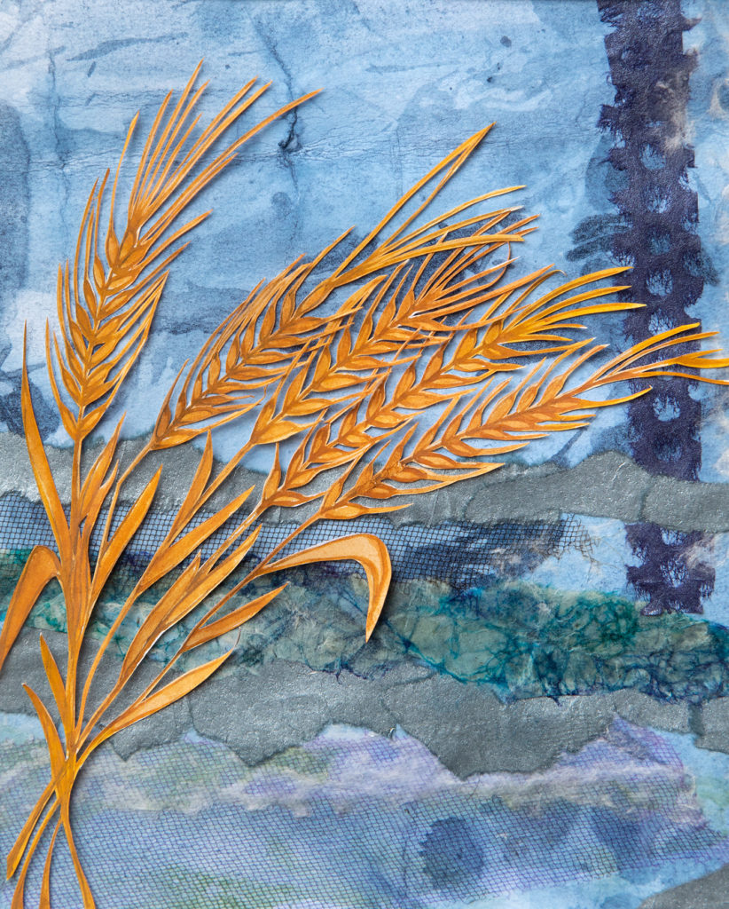Illustration by Galia Goodman.
Passover is the path back to basics—the earth, the wheat, and water—and our essential selves. Passover teaches that freedom comes when we rid ourselves of the burden of too much. For now, we simply admire the matzah and reflect on it—the root food of our peoplehood.
The broken matzah is symbolic of our own brokenness and the brokenness of the world. Some of us have broken with the past—we may have lost a sense of history and a connection to our ancestors. Others may feel broken or detached from our earthy home. We may have lost touch with the natural world and all that it gives us freely each day.
The whole matzah represents wholeness and freedom—it is the food of liberation that the Israelites ate as they hurried out of Egypt. It helps us to retrieve lost parts of ourselves so we may become whole again.
-- Rabbi Ellen Bernstein

יחץ

חלק גדול יניח לאפיקומן כי הוא מצוה חשובה שהוא לנו במקום הפסח (מהרי"ל ב"ח). ונוהגין לכרכו במפה (ראה זח"ב קנ"ח, ב'. טושו"ע סתע"ג) זכר למשארותם צרורות בשמלותם (ראה רוקח, ב"י) ולהניחו בין הכרים (המנהיג) שלא יבא לאכלו בתוך הסעודה.

