Jewish Artist Lab Feb. 16, 2021
Broken Hearted / Whole Hearted

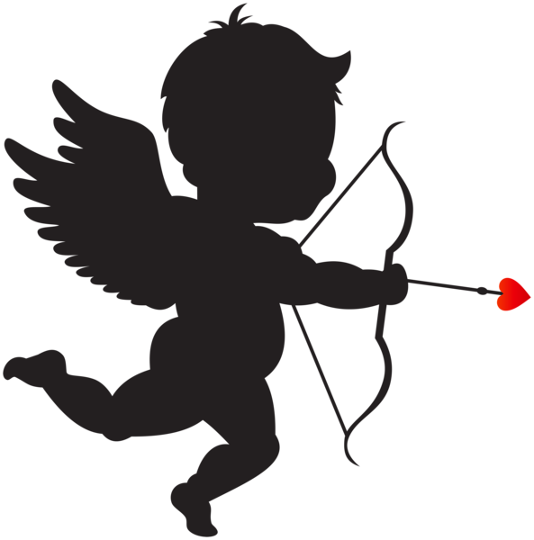

Homework:
Write a note to your partner…what I love about partnering with you is……

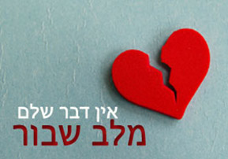
A Saying by Rabbi Menachem Mendel of Kotzk (1787-1859)

“There is nothing more whole than a broken heart.”

אין שלם מלב שבור

A Story by Reb Simcha Bunim of Peshischa (1765-1875)

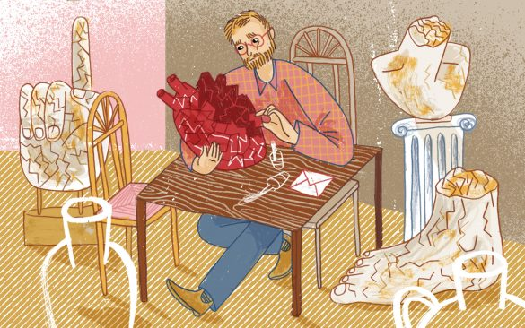
("הָרֹפֵא לִשְׁבוּרֵי לֵב וּמְחַבֵּשׁ לְעַצְּבוֹתָם" (תהלים קמז, ג
רבי שמחה בּוּנים מפְּשיסחָה אמר על כך כי "לב שבור הוא טוב מאוד": את הלב השבור מרפאים בסילוק העצבות, ולא באיחוי השבר. וזו מעלתם של הצדיקים: גם כשלבם נשבר הם מצליחים להיות שמחים. מעלה שאליה כל אדם צריך לקוות – שאלוהים ייתן לו לב טהור ושבור שאיננו עצוב. על כך אמר רבי אייזיק מלֶנטשנֶה, כי ראוי שהלב יהיה שבור, אך ראוי גם שבו בזמן יהיה הלב שלם. והלב השבור והשלם יהיו באדם יחדיו, בשלמות אחת.
[God] heals broken hearts and bandages their sadness. –Psalms 147:3

Reb Simcha Bunim of Peshischa said about this verse: “ a broken heart is very good.” A broken heart is healed by casting out sadness, and not by patching up the fracture. And this is the virtue of the tzaddikim: Even when their heart is broken, they manage to be happy. This is a virtue everyone should strive for—that God will grant him a pure and broken heart that is not sad. Rabbi Isaac from Lentshene said, “Better that the heart be broken and better yet that at the same time it be a whole heart. A broken and whole heart exist together within a person in one shlemut (wholeness).”

Discussion Questions
- Menachem Mendel of Kotzk was the student of Rabbi Bunim of Peshischa. What’s similar and what’s different in their writing?
- What does Reb Simcha Bunim mean when he says “ A broken heart is healed by casting out the sadness and not by patching up the fracture”?
- “Better that the heart be broken and better yet that at the same time it be a whole heart. A broken and whole heart exist together within a person in one shlemut (wholeness).” How do you understand this paradox? Have you felt it?
Extra time discussion questions
- Rabbi Bunim suggests that a tzadik can turn his broken heart from sadness to joy. How does that happen and why would that be a quality a righteous person possesses?
- Why does Cupid shoot an arrow through someone’s heart to make them fall in love with someone? What does that fractured heart suggest about the nature of love? (trivia question—do you know what type of bow is depicted especially in Renaissance art? See end of the sheet for the answer)
- in Biblical Hebrew the heart represents the mind. It is the “the seat of the emotional and intellectual life. “ In modern parlance, we’d think of the heart as the mind. In Biblical usage the heart has three special functions: knowing, feeling, and willing. So, when God hardens Pharaoh’s heart, he takes away his free will. What meaning of “heart” do you think Reb Bunim has in mind?

A Song by Naomi Shemer

Ain Davar (It’s Nothing or There is nothing.) Translation by Meryll
https://www.youtube.com/watch?v=idxeAB4kNVI
ליל אביב מלא ירח
עוד מעט וייגמר
אמהות שרות לילד
הזהר והשמר
אמהות נותנות לילד
מדבשן וחלבן
ומאחורי הדלת
מצפה לו גדי לבן
אין דבר אין דבר
שלם יותר מלב שבור
וזועק יותר מן הדממה
אז לכבוד עמוד השחר
העיניים נפקחות
והרבה צרות מאמש
נסלחות ונשכחות
וכולם יודעים לשמוע
וכולם שבים לראות
בחלום הרי כולנו
ילדים יפים מאוד
אין דבר אין דבר...
זה האות לסוף הלילה
ולהתחלת היום
אנשים אשר הכרנו
זה לזה אומרים שלום
בליבך אולי נקשר עוד
צל הלילה שעבר
אמהות אומרות לילד
לא נורא ואין דבר
אין דבר אין דבר...

A spring evening, a full moon
In a little while it’ll end.
Mothers sing to their child
“Be careful!” and “Watch out!”
Mothers give their child
Honey and milk.
Behind the door
A white kid awaits.

Chorus:
There is nothing, there is nothing
More whole than a broken heart
That screams more from the silence.

Then, in honor of the dawn,
Eyes are opened
And many of last night’s troubles (tzarot)
Are forgiven and forgotten.
Everyone knows to listen
Everyone returns to see
Behold in a dream
All of us are lovely children.

Chorus

This is the sign for the end of night
And the beginning of the day.
People whom we knew
Say “shalom” to one another.

Perhaps in your heart we’ll be in touch again.
In the shadow of the past night
Mothers say to their children
“It’s not so bad, it’s nothing.”

Chorus

Group Work (20 minutes)
The song on youtube includes one photo. If you had to select art to accompany this song, what would you choose or create? You may want to discuss the first four discussion questions to help your group generate an artistic response.

Discussion Questions
- Naomi Shemer hints how this mother’s heart was broken. What do you think was the cause?
- Do mothers in this song overcome their broken heart? How?
- What Biblical imagery does the line “and a white kid awaits” (kid means little goat here) evoke?
- Naomi Shemer mixes singular and plural, past and future. Her knowledge of grammar is terrific so this is purposeful. Why is she making this choice?
Extra discussion questions
- How does Naomi Shemer play with the Hassidic masters’ ideas?
- There is another Israeli song with the lyrics broken hearted, whole hearted—you can hear it on youtube: https://www.youtube.com/watch?v=bErZt-l8qRM&lc=Ugjzqi6dxf66J3gCoAEC . Click
- Click on the facebook link to see the Hebrew lyrics. If you know Hebrew, compare this song to Shemer’s. What art would you use to accompany his song?

Meta question
What’s the relationship between broken and whole?

An Invitation to Brainstorm

- What Jewish rituals do you know that include breaking or tearing?
- What Jewish rituals do you know that break our hearts?
- What Jewish rituals do you know that heal our hearts?

Trivia Answer + Raphael’s Triumph of Galatea
*Cupid’s bow is called the S bow or the Tatar’s bow. It was used by Persians and Mongols who fought on horseback because of its accuracy and ease of use while riding. 