Jewish Artist Lab Dec. 15, 2020
From Brokenness to Wholeness with a Dose of Imagination

Source #1--I Maccabees 4:36-59 (Maccabees is part of the Apocrypha*)
36 Then Judah and his brothers said,
Now that our enemies are crushed, let us go up to purify and dedicate the sanctuary.
37 The whole army gathered together and went up to Mount Zion.
38 When they saw the sanctuary desolate, and the altar profaned, and the doors burned up, and shrubs growing in the courts as in a forest or in one of the mountains, and the priests’ chambers torn down;
39 They tore open their clothes, and uttered great lamentation, and cast ashes upon their heads,
40 And fell down flat to the ground upon their faces, and blew an alarm with the trumpets, and cried toward heaven.
41 Then Judah appointed men to fight the garrison in the fortress, until he had purified the sanctuary.
42,43 He chose priests without blemish and adherents of the Law and they purified the sanctuary, and they carried out the defiled stones into an unclean place.
44 They deliberated what to do about the altar of burnt offerings which was profaned.
45 A good idea occurred to them—to take it down so that it might never be thrown up to them that the heathen had polluted it. So they took down the altar
46 and deposited the stones on the Temple Mount in a convenient place, until a prophet would come to teach them what should be done with them [the stones].
47 Then they took whole stones that had not been worked with iron according to God’s Torah, and built a new altar like the former one
48 And they built the sanctuary and the interior of the Temple, and consecrated the courts.
49 They made new holy vessels, and they brought the lampstand (menorah), and the altar of incense and the table into the Temple.
50 They burned incense on the altar, and they lit the lamps that were on the menorah to light the Temple.
51 They put the loaves of bread on the table, and hung the curtains, and finished all the works which they had begun.
52,53 They arose early on the twenty-fifth day of the ninth month, which is called Kislev, in the hundred forty and eighth year [164 BCE] and offered sacrifices according to the law upon the new altar of burnt offerings.
54 At the time and on the day the heathen had polluted it, it was rededicated (ויחנכו) with songs, and harps and lutes and cymbals.
55 Then all the people fell upon their faces, worshipping and praising the God of heaven, who had given them strength and redemption.
56 They celebrated the dedication of the altar eight days and offered burnt offerings with gladness.
57 They decked also the forefront of the temple with crowns of gold, and with shields; and they renewed the gates and the chambers, and hung doors upon them.
58 Thus was there very great gladness among the people, for that the reproach of the heathen was put away.
59 Judah and his brothers with the whole congregation of Israel ordained that the days of the dedication of the altar should be kept in their season from year to year by the space of eight days, from the twenty-fifth day of Kislev, with mirth and gladness.

Questions
- What’s missing from this account of Hanukkah that you expect to see in a history of the holiday?
- A lot of emotion is embedded in this section. If you had to graph the emotion throughout this section, what would your graph look like?
- What’s the mood of the Maccabees (Judah and his brothers) when they first enter the Temple? Why?
- What series of decisions and actions change the mood?
- Why do you think the Temple must be built of whole stones and not hewn stones?
- The Maccabees don’t create new art to commemorate their rededication of the Temple. What’s their medium for commemoration? How does that theme repeat in Jewish life?
- The Maccabees were soldiers. What other action could their army have taken after they defeated Antiochus’s forces and found the Temple in ruins?
- Most armies make their prisoners of war clean up from the destruction. In the Book of Maccabees we see an army move from a force for destruction to a force for construction. They move from breaking to making whole. What impact do you think that had on the individual soldiers?

Source #2 Shabbat 21b (from the second section of the Talmud)
מַאי חֲנוּכָּה? דְּתָנוּ רַבָּנַן: בְּכ״ה בְּכִסְלֵיו יוֹמֵי דַחֲנוּכָּה תְּמָנְיָא אִינּוּן דְּלָא לְמִסְפַּד בְּהוֹן וּדְלָא לְהִתְעַנּוֹת בְּהוֹן. שֶׁכְּשֶׁנִּכְנְסוּ יְווֹנִים לַהֵיכָל טִמְּאוּ כׇּל הַשְּׁמָנִים שֶׁבַּהֵיכָל. וּכְשֶׁגָּבְרָה מַלְכוּת בֵּית חַשְׁמוֹנַאי וְנִצְּחוּם, בָּדְקוּ וְלֹא מָצְאוּ אֶלָּא פַּךְ אֶחָד שֶׁל שֶׁמֶן שֶׁהָיָה מוּנָּח בְּחוֹתָמוֹ שֶׁל כֹּהֵן גָּדוֹל, וְלֹא הָיָה בּוֹ אֶלָּא לְהַדְלִיק יוֹם אֶחָד. נַעֲשָׂה בּוֹ נֵס וְהִדְלִיקוּ מִמֶּנּוּ שְׁמוֹנָה יָמִים. לְשָׁנָה אַחֶרֶת קְבָעוּם וַעֲשָׂאוּם יָמִים טוֹבִים בְּהַלֵּל וְהוֹדָאָה.
The Gemara asks: What is Hanukkah, and why are lights kindled on Hanukkah?
The Gemara answers: The Sages taught in Megillat Ta’anit: On the twenty-fifth of Kislev, the days of Hanukkah are eight. One may not eulogize on them and one may not fast on them. What is the reason?
When the Greeks entered the Sanctuary they defiled all the oils that were in the Sanctuary by touching them. And when the Hasmonean monarchy overcame them and emerged victorious over them, they searched and found only one cruse of oil that was placed with the seal of the High Priest, undisturbed by the Greeks. And there was sufficient oil there to light the menorah for only one day. A miracle occurred and they lit the menorah from it eight days.
The next year the Sages instituted those days and made them holidays with recitation of hallel and special thanksgiving in prayer and blessings.**
Questions
- There is a 700 year gap between the time the Maccabees fought Antiochus and his army and the time when the rabbis offered this explanation. Why do you think the Talmudic rabbis focused on the miracle of the oil? What does that add to the historical account from I Maccabees?
- Where do you see the themes of brokenness and wholeness in the Hanukkah holiday?
- Combining both accounts, who is responsible for the brokenness? Who is responsible for rebuilding and recreating the wholeness of the Temple?
- In last month’s section from Exodus Moses had to make the ark for the tablets. In this month’s section from Maccabees Judah and his soldiers clean out the Temple and rebuild it themselves. What do you think might be the value of doing this work with one’s hands?
- Many of the early songs of the halutzim (pioneers in Israel in the early 20th century) wrote and sang songs that celebrated the work on one’s own hands.
- The song Anu Banu Artza is a very simple melody with simple Hebrew lyrics-it says “We came to Israel to build and to rebuild ourselves in the country.” What’s the message about aliyah? Why would Jews need to rebuild themselves? Does working with your hands and creating rebuild you in any way?
https://www.youtube.com/watch?v=gzOWjdw4IJY

Source 3: Pesikta Rabbati 2:1*
ולמה מדליק נרות בחנוכה אלא בשעה שנצחו בניו של חשמונאי הכהן הגדול למלכות יון שנאמר ועוררת בניך ציון על בניך יון (זכריה ט' י"ג) נכנסו לבית המקדש מצאו שם שמונה שפודין של ברזל וקבעו אותם והדליקו בתוכם נרות

Why do we light candles on Hanukkah? Because at the time the Hasmoneans (descendants of the High Priest during the Greek rule) as it is written in Zechariah 9:13 “I will stir up your sons, O Yavan (Greece) and will make you (Israel) like the sword of a mighty man” entered the Temple, they found eight iron spears and designated them [and fashioned them as a menorah] and lit candles in them.
- Despite the tortured language, can you discern what the Maccabees found and that they did with the weapons?
- It’s prohibited to use iron in the Temple. Surely, the Hasmoneans who were kohanim knew that. Why would they refashion spears into a ritual object?
- How does this legend fit with our theme of brokenness and wholeness?
Fun Hebrew fact—שפודין which I translated as spears in this context is used in modern Hebrew for skewered meat from the grill.

Consider with your Hevruta
Can you think of any other Jewish holiday that commemorates physical destruction and rebuilding? Can you think of any other Jewish holiday that commemorates destruction of the spirit and rebuilding the spirit?
What message about the Jewish view of history is conveyed when we include commemoration of the brokenness and the movement back to wholeness?
If you had to make your own Menorah to celebrate the passage from brokenness to wholeness what would it look like?
Many of the early songs of the halutzim (pioneers in Israel in the early 20th century) celebrated the work on one’s own hands.
The song Anu Banu Artza is a very simple melody with simple Hebrew lyrics-it says “We came to Israel to build and to rebuild ourselves in the country.” What’s the message about aliyah? Why would Jews need to rebuild themselves? Does working with your hands and creating rebuild you in any way?
https://www.youtube.com/watch?v=gzOWjdw4IJY

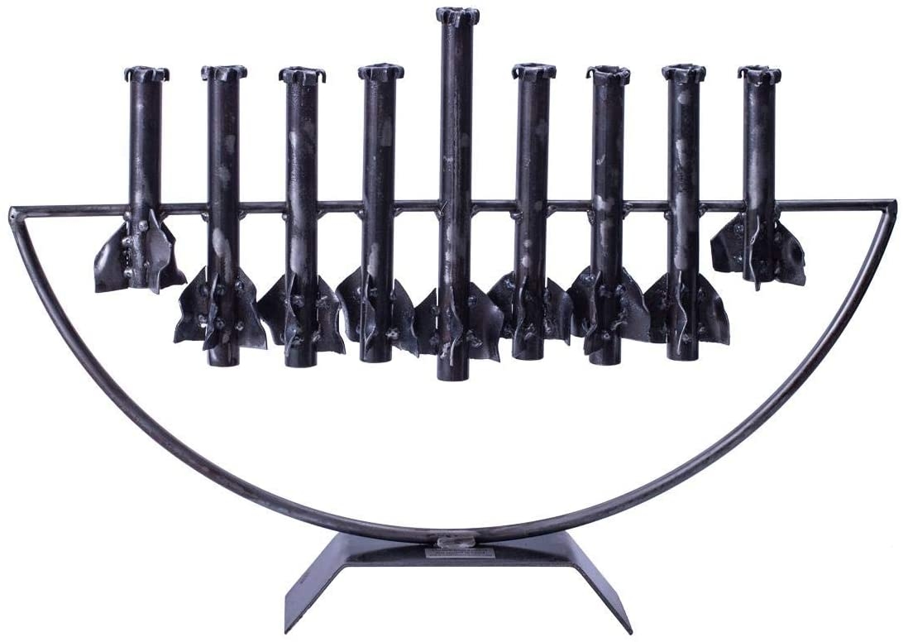
Qassam Rocket Menorah

Hevruta hints

*Apocrypha. The Apocrypha (Hidden Writings) was originally written in Greek and found in the Septuagint, the Greek version of the Tanakh. These are books that didn’t make the cut for the Tanakh. I Maccabees was probably written in the latter part of the 2nd century BCE. For more information, see https://www.myjewishlearning.com/article/omitting-the-maccabees/

*Pesikta Rabbati is a midrash on hagim, holidays. It was compiled around 845 CE in Europe but the sources are most likely from 6th or 7th century CE Palestine.

There is an overload of material. Choose what you think will resonate with your partner. If something doesn’t work, try a different approach.

**Caught in the thicket --------נאחז בסבך

Your partner may ask “did this really happen” or “how did the rabbis know this happened if they wrote down the miracle 700 years after the event”?

Historical response: The Book of Maccabees represents a historical reality from the viewpoint of Judah and his brothers. There was a war, the temple was desecrated (not completely destroyed), and the temple was rededicated.

Scholar Daniel Sperber affirms the statement from Pesikta Rabbati and claims that the new menorah was fashioned from spits—the weapons the Greeks left behind. The fleeing soldiers had taken anything silver and gold. As the Temple amassed more wealth the redone menorah was first coated in silver, then gold.

Response to a miracle: As for the Talmudic account of the oil lasting eight days—this is a midrash. The question is what were the rabbis teaching by recounting this miracle? You can also refer to the special prayer for Hanukkah if you’d like to see how the rabbis rewrite the military account. Below is that special prayer mentioned in the Talmudic passage. This would work well with partners who already are well versed in the Book of Maccabees because it shows the rabbinic emphasis on God’s agency rather than human agency.

Prayer for Hanukkah said during Amidah and Birkat haMazon
עַל הַנִּסִּים וְעַל הַפֻּרְקָן וְעַל הַגְּבוּרוֹת וְעַל הַתְּשׁוּעוֹת וְעַל הַנִּפְלָאוֹת וְעַל הַנֶּחָמוֹת שֶׁעָשִׂיתָ לַאֲבוֹתֵינוּ בַּיָּמִים הָהֵם בַּזְּמַן הַזֶּה.
We thank You for the miracles, for the liberation, for the mighty acts and victories and for the wars which You waged for our ancestors in those days on this occasion.
לחנוכה -- בִּימֵי מַתִּתְיָהו בֶן יוֹחָנָן כֹּהֵן גָּדוֹל חַשְׁמוֹנָאִי וּבָנָיו כְּשֶׁעָמְדָה מַלְכוּת יָוָן הָרְשָׁעָה עַל עַמְּךָ יִשְׂרָאֵל לְהשַׁכִּיחָם מִתּוֹרָתָךְ וּלְהַעֲבִירָם מֵחֻקֵּי רְצוֹנָךְ וְאַתָּה בְּרַחֲמֶיךָ הָרַבִּים עָמַדְתָּ לָהֶם בְּעֵת צָרָתָם רַבְתָּ אֶת רִיבָם דַּנְתָּ אֶת דִּינָם נָקַמְתָּ אֶת נִקְמָתָם מָסַרְתָּ גִבּוֹרִים בְּיַד חַלָּשִׁים וְרַבִּים בְּיַד מְעַטִּים וּטְמֵאִים בְּיַד טְהוֹרִים וּרְשָׁעִים בְּיַד צַדִּיקִים וְזֵדִים בְּיַד עוֹסְקֵי תוֹרָתֶךָ וּלְךָ עָשִׂיתָ שֵׁם גָּדוֹל וְקָדוֹשׁ בְּעוֹלָמָךְ וּלְעַמְּךָ יִשְׂרָאֵל עָשִׂיתָ תְּשׁוּעָה גְדוֹלָה וּפֻרְקָן כְּהַיּוֹם הַזֶּה וְאַחַר כָּךְ בָּאוּ בָנֶיךָ לִדְבִיר בֵּיתֶךָ וּפִנּוּ אֶת הֵיכָלֶךָ וְטִהֲרוּ אֶת-מִקְדָּשֶׁךָ וְהִדְלִיקוּ נֵרוֹת בְּחַצְרוֹת קָדְשֶׁךָ וְקָבְעוּ שְׁמוֹנַת יְמֵי חֲנֻכָּה אֵלּוּ לְהוֹדוֹת וּלְהַלֵּל לְשִׁמְךָ הַגָּדוֹל.
It was In the days of the Mattityahu, son of Yohanan, the High Priest, a Hasmonean, and his sons, that the wicked Hellenistic regime confronted Your people Israel to make them forget Your Torah, and to drive them away from the laws of Your will. Then You in Your great mercy stood up for them in their time of trouble. You pleaded their cause, argued their case, and avenged their wrong. You delivered the strong into the power of the weak, the many into the power of the few, the impure into the power of the pure, the wicked into the power of the righteous, and the sacrilegious into the power of those immersed in Torah. Thus You made for Yourself a great and holy Name in Your world, and for Your people Israel You brought about a great victory and liberation on this day. And afterwards, Your children came into the sanctuary of Your house, cleared Your holy place, purified Your Temple, and kindled lights in Your holy courts, and they established these eight days of Hanukkah for giving thanks and praise to Your great Name.
How does the prayer recast the history of Hanukkah? Why?
In the haftarah for Hanukkah from Zechariah 4:6 we read, “Not by might, nor by power, but by My spirit—said the Lord of Hosts.”
Do you feel there the emphasis on the military victory and restoration of the Temple by the Hasmoneans is at odds with the emphasis on God’s role in history? What philosophical tension m do you see playing out in these sources?

Art Connections
The Light of Fire (Israeli documentary about an artist who loses all his work in a fire).
https://www.streamisrael.tv/videos/the-light-of-fire
Anu Banu Artza (1920) https://www.youtube.com/watch?v=gzOWjdw4IJY
Scholarly article on the origin of the oil in the Temple story: https://www.sefaria.org/sheets/85895?lang=bi
An even more scholarly article on the Hanukkah legend
Noam,Vered. The Miracle of the Cruse of Oil. The Metamorphosis of a Legend. HUC Annual, Vol 73 (2002).
Public Menorah designed for Boston by Caron Tabb: https://www.bostonglobe.com/metro/newton/2019/12/20/newton-artist-universal-menorah-featured-museum-fine-arts/JdWJV3zAxAj5DNolnZLlhN/story.html
Hanukkah song lyrics with contrasting views of the reason for the Maccabean victory.
Rock of Ages http://hebrewsongs.com/?song=maoztzur (13th century)
Mi Yimalel , Who can retell.. https://www.myjewishlearning.com/article/mi-yimalel-who-can-retell/ (mid 20th century)

